Moored Buoy Losses in Early 2001 as a Result of Severe Winter Storms Around Alaska

by

Gary S. Bahret
Electrical Engineer, NDBC Operations Branch
Leader, Network Support Team

David B. Gilhousen
Meteorologist, NDBC Operations Branch
Leader, Data Products Team

and

Eric A. Meindl
Chief, NDBC Operations Branch

ABSTRACT

Severe winter weather led to significant losses in the National Data Buoy Center’s (NDBC) moored buoy fleet during early 2001. In one case, a 6-meter (6-m) boat-shaped NOMAD-VE (Navy Oceanographic and Meteorological Automatic Device - Value-Engineered) hull sank. In the other, a 12-meter (12-m) “monster” discus buoy capsized. The cases are described, including weather factors, along with lessons learned and future plans.

1. INTRODUCTION

The National Data Buoy Center (NDBC), an agency within the National Oceanic and Atmospheric Administration’s (NOAA) National Weather Service (NWS), has operated a large moored buoy network for over 20 years. The network is an important part of the United States of America (U.S.) operational marine warning and forecast infrastructure providing in-situ observations that complement radar and satellite technologies.

The buoys are designed to operate unattended for at least two years. They automatically sample wind, atmospheric pressure, air and sea surface temperature, and sea state. They transmit the observations back to shore at least every hour via NOAA’s Geostationary Operational Environmental Satellite (GOES) communications system. Although ruggedized, entire moored buoy systems or components sometimes are damaged or fail on their own and stop reporting. However, excluding ship collisions, catastrophic buoy losses are very rare. During February 2001, two such events occurred within days of each other around Alaska due to severe storms. In one case, a buoy capsized on station in the Bering Sea (Station 46035); in the other, the buoy sank on station near the entrance to Prince William Sound (Station 46061) and was lost (Figure 1). The losses are estimated to be close to $400K (U.S.). Both events are described below, along with causal circumstances and subsequent actions.

2. BERING SEA BUOY CAPSIZING

Bering Sea station 46035 was established near 56.9 N 177.8 W in September 1985. Since that time, different 12-meter (12-m) discus buoy hulls, sometimes referred to as “monster buoys,” had been deployed there. They are constructed of steel, are 12-m across with a 10-m high mast, and weigh approximately 80,000 kilograms (kg) when configured for deployment. A hull type in existence since before NDBC was established, it has never been known to have capsized when the mooring was attached. The 12-m buoy at Station 46035, identified as “12D02,” is believed to have capsized on Feburary 8, 2001, during a fierce storm.

Available evidence indicates the buoy probably flipped between 1824 Universal Coordinated Time (UTC) when a final Tiros Drift Detection (TDD) position was received, and 1904 UTC when the next scheduled weather observations were not received. Table 1 shows the final 36 hourly meteorological and wave measurements. The highest 8-minute (8-min) average wind, sampled at 1 Hertz (Hz), was 27.2 m/s, recorded at 1100 UTC, while the highest significant wave height, 14.78 m, occurred at 1400 UTC*. These wave heights are among the highest ever recorded by NDBC buoys. The highest value ever recorder at this station was 15.37 m; the all-time record is 16.91 m at north Pacific Station 46003.

An evaluation of several studies and simulations indicates the last reported waves were capable of capsizing the buoy. Scale model tests conducted by Petrie and Hoffmann (1977) indicated that a wave height 1.5 times the diameter of the discus hull was necessary to make it capsize. This means an 18 m maximum wave is necessary to capsize a 12-m discus buoy. Hamilton (1980) used this condition and classic Longuet-Higgins statistical distribution of extreme wave heights to calculate that an 18 m high wave could occur every hour if the significant wave height was as low as 11.54 m.

In another study, conducted by Nath and Chester (1979), discus buoy models were tested in the Oregon State University wave flume to investigate capsizing conditions. They determined a wave steepness parameter, κ, from the one-dimensional wave energy spectra, along with a ratio between significant wave height and the diameter of the discus buoy, η. Figure 2 is based on their report and shows that cases of capsizing where both κ and η are large, a high percentage of breaking waves should occur. This is an area in which sea state observations from station 46035 fell during the time it is most likely to have turned over.

The meteorological pattern resembles others that caused capsizing of NDBC’s slightly smaller 10-m discus buoys in the 1970s (Hamilton 1980). A low pressure trough passed the buoy just after 1800 UTC, causing the wind to shift to the west-northwest. The air temperature would then have cooled rapidly, resulting in destabilization of the atmosphere and onset of stronger and gusty winds. Non-linear wave action between the existing southwesterly swell and crossing seas building after the wind shift may have created sufficient energy to capsize the buoy. The possibility also exists that the winds, which were near hurricane force, may have placed a force on a large portion of the underside of the 12-m hull that may have become exposed by the chaotic wave action. Also, note from Table 1 that the air temperature was below freezing for most hours after 0200 UTC, raising the possibility of superstructure icing and added weight on the large mast.

The buoy was towed in its inverted position by commercial tug to Dutch Harbor, Alaska, in July 2001, where it was righted (Figure 3). It will remain there indefinitely in wet storage.

3. BUOY SINKING NEAR THE ENTRANCE TO PRINCE WILLIAM SOUND, ALASKA

NDBC was operating a 6-m NOMAD buoy at station 46061 (60.2 N 160.8 W). The buoy was set on September 12, 2000. On February 1, 2001, data were noted from the wave measurement system indicating the hull was floating slightly bow down. Since the meteorological conditions had been very cold and windy, the bow down condition was attributed to added weight from superstructure icing which is not unusual in these waters. In fact, a short-lived problem with wind data had been documented at the station during December 2000 that was attributed to icing when it cleared up the following day. However, as the attitude anomaly continue to worsen, personnel aboard a U.S. Coast Guard (USCG) patrol aircraft observed the buoy bow down but with no visible sign of ice or damage. By the time arrangements could be made for a vessel on February 8, recovery was no longer possible due to flooding. In fact, it arrived just in time to photograph the hull going down (Figure 4).

Since the hull was lost, there is no physical evidence to determine the exact cause. However, there are noteworthy clues (NDBC Technical Document 01-03). When the hull was received from the manufacturer in May 1995, air leaks were noted during tests to determine how air tight the hull was. In addition, the hatch coaming and flatness of the flange between the forward mast and its attachment point on the deck were noted to require attention. Also, the fit between hatch gaskets at the perimeter of the hatch covers and the coaming on the deck had been a problem on at least four 6-m NOMAD hulls, including the one that sank. These problems noted in both the air and chalk tests were thought to have been corrected.

Another clue to this sinking may be related to the increase in size of solar panels mounted to the forward mast of the buoy. A new design had increased the area of solar panels by 1.2 times to 8,890 square centimeters (cm²) (1,378 square inches) per side, and had oriented them more vertically. These modifications were intended to increase power to recharge batteries and extend service life in the far northern latitude, but it increased the potential wind loading on the forward mast as well. The mast is attached to a hollow stump on the deck; a rubber gasket where they meet makes a water-tight connection. Sensor cables are routed in the interior of the mast, through the stump, and into the buoy. However, the lack of braces between the upper part of the mast and the deck can place considerable torque where the mast and flange meet. Several prolonged periods of 8-min average winds greater than 15 meters per second (m/s) had been reported by the buoy in the preceding five weeks, including at least 40 hours, mostly during January, when 5-second (sec) peak winds exceeded 25 m/s. Significant wave heights frequently exceeded 5 m on more than 60 hourly observations, including one measurement of 10.94 m on January 19.

Based on photographic evidence and the environmental observations, the most likely scenario leading to the sinking was that prolonged high winds and buoy motion from the waves produced excessive, pulsating stress on the forward mast, rocking it fore and aft, weakening the gasket between the mast and mast stump. Since the mast and stump are constructed of aluminum alloy, it is even possible the flange area was bent out of shape, or a weld in the area actually cracked, or both. This led to a minor leak that permitted water to enter when waves broke over the forward part of the deck. Since slow air leakage is acceptable in the NDBC air tests, water entering the hull in the forward internal compartment displaced air in the hull, flooding it progressively aft. Due to cable runs, the seal between the four internal compartments is not air tight. As the hull rode increasingly lower and the forward deck became inundated, water entry accelerated, building air pressure forced air out through the two aft hatch gaskets, and the buoy sank.

4. LESSONS LEARNED

While moored buoys provide reliable, diverse types of environmental observations, operating and maintaining such a network is costly under the best of circumstances. Catastrophic loss is rare and results in an unexpected, significant, direct budget impact. The direct cost to recover 12D02 from the Bering Sea was approximately $170K (U.S.). Scuttling was seriously considered, but since the ballast included 37,850 liters (10,000 U.S. gallons) of ethylene glycol (“antifreeze”), it was ruled out due to environmental concerns. The cost to construct a 6-m NOMAD buoy is approximately $135K (U.S.), and when costs to prepare, equip, and integrate are added, it escalates the cost to approximately $240K (U.S.). For the time being, the 6-m NOMAD “replacement” will translate into a smaller spare hull inventory. Obviously, it is critical that NDBC correct anything it can control that may have led to the loss.

In the case of 12D02, this was a unique event in over 30 years of NDBC operations. Reasonable design criteria were established, but they were exceeded during an extremely severe weather event. Also, these hulls are no longer fabricated due to the expense - approximately $250K to $350K (U.S.) for the base hull, plus preparation expenses.

The 6-m NOMAD sinking is being addressed, however, since this is the preferred equipment in the open ocean. Some are being built for the Alaska Buoy Network Expansion (ABNE), (Implementation Plan for the NWS Alaskan Buoy Network Expansion, 2001), and there are design questions that need to be addressed. Some actions have already been taken. A new mast brace between the upper part of the forward mast and the deck has been added. This design is being tested, and it should reduce stress at the mast stump. A solar panel configuration is being considered that will provide space between the panels and reduce the flat planar surface facing the direction of the bow. Since NOMAD hulls tend to turn into the wind and waves, this should deflect some wind and wave energy, further reducing stress on the mast. Further, NDBC will conduct tests to determine whether placing non-absorbant materials in the fore and aft interior compartments will keep a NOMAD afloat even if it takes on water. Also, the internal cable runs may be changed, limiting them to the two middle compartments. Finally, NDBC is re-evaluating air test criteria and procedures to see if they are adequate.

5. CONCLUSIONS

NDBC experienced unusually large losses due to two catastrophic events within its network around Alaska in February 2001. It is believed that in one case, it is neither necessary nor practical to alter its practices or perform redesign because very rare, extremely severe weather was the cause. In the other case, however, risk of future loss may be decreased by improved system design and better test procedures that will make the 6-m NOMAD more seaworthy during severe weather. This is extremely important since that hull type will be used in the ABNE.

REFERENCES

Gilhousen, David B., The Capsizing of a 12-M Discus Buoy at 46035, National Data Buoy Center, Sea Worthy, October 2001 issue.

Hamilton, Glenn D., 1980: Environmental Conditions Associated With Capsizing of Discus Buoys. NOAA Data Buoy Office Report F-820-1. 45 pp.

Implementation plan for the NWS Alaskan Buoy Network Expansion, National Data Buoy Center, June 30, 2001, 27pp.

Nath, John H. and S.T. Chester, 1979: Steep Wave Spectrum Relations and Buoy Reliability. Report to the NOAA Data Buoy Office, Contract 03-78-G 03-0500, by School of Engineering, Oregon State University, Corvallis, OR, 49 pp.

NDBC Technical Document 01-03, The Loss of 6N40, National Data Buoy Center, December, 2001, 83 pp.

Petrie, G.L. and D. Hoffman, 1977: Validation of a Time Domain Simulation of Buoy Motion in Breaking Waves. Technical Report No. 7753 to the NOAA Data Buoy Center by Hoffman Maritime Consultants.

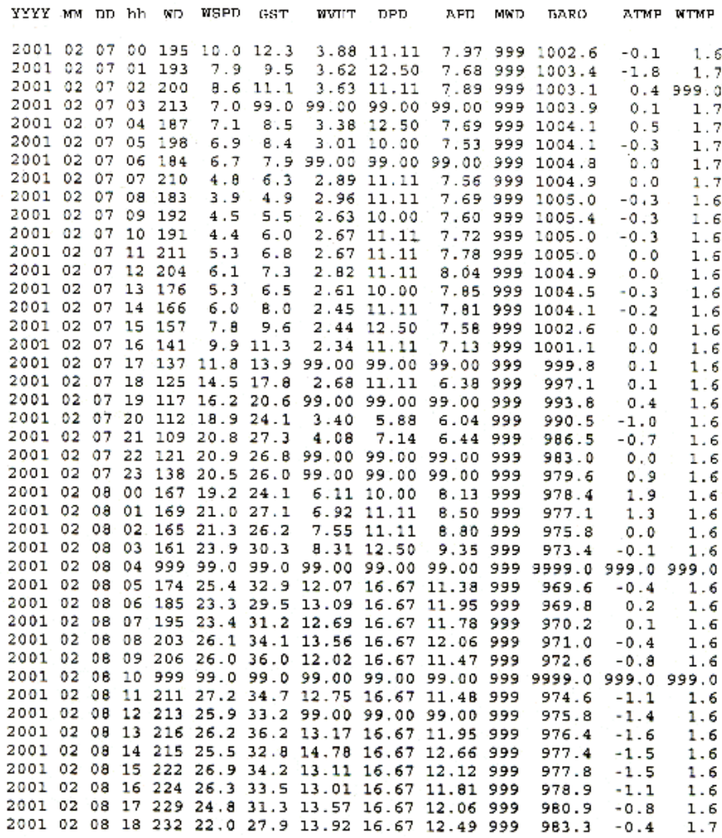

Table 1 - The last observations transmitted by the DACT payload on 46035.

YYYY is the year, MM is the month, DD is the day, hh is the hour in UTC, WD is the wind direction in degrees true, WSPD is the 8-minute average wind speed in m/s, GST is the highest 5-s average in the 8-minute period, WVHT is the significant wave height in m, DPD is the dominant wave period in s, APD is the average wave period in s, BARO is the sea level pressure in hPa, ATMP is the air temperature in degrees Celsius, and WTMP is the water temperature in degrees Celsius. Consecutive 9's denote missing data.

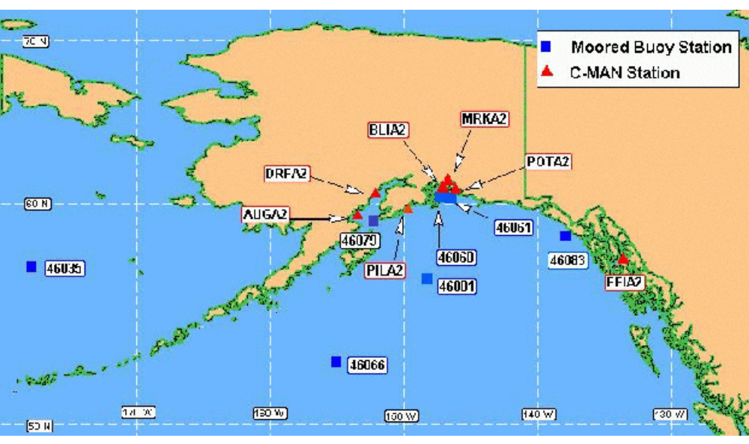

Figure 1 - NDBC Moored Buoy Network around Alaska.
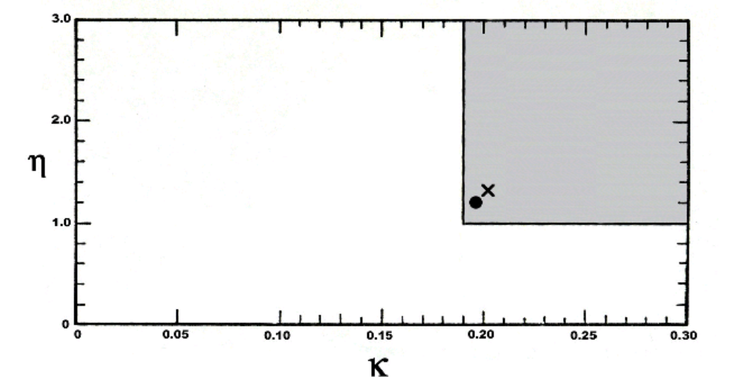
Figure 2 - Nath and Chester study results showing wave steepness parameter, κ, from the one-dimensional wave energy spectra, along with a ratio between significant wave height and the diameter of the discus buoy, η Conditions experienced when 12D02 is believed to have capsized are shown by (x).
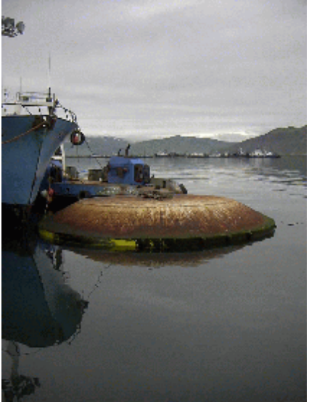
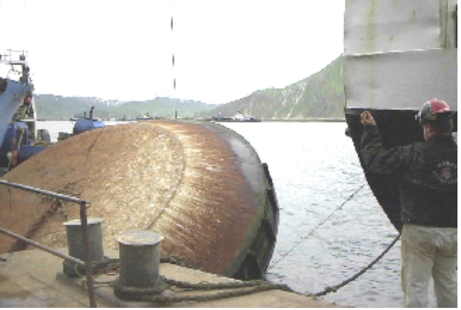

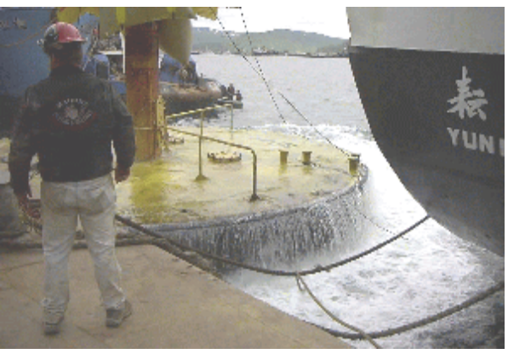

Figure 3 - 12D02 being righted in Dutch Harbor, AK after being towed from where it capsized at station 46035.
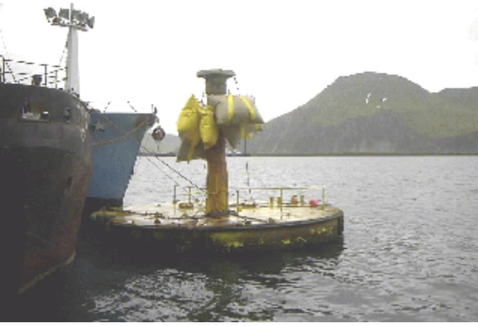
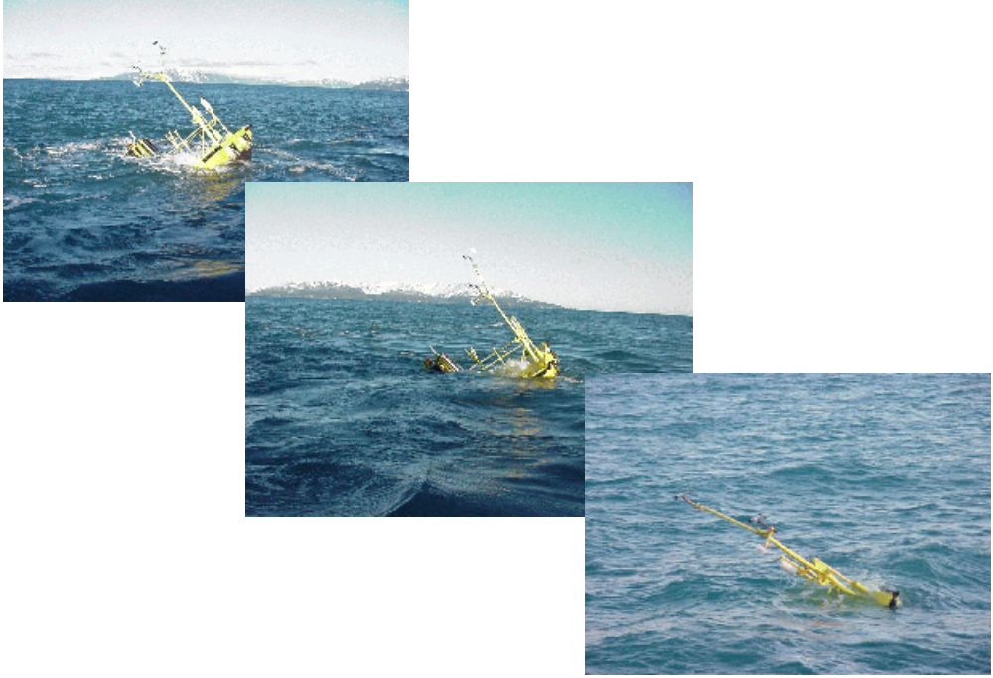

Figure 4 - 6N40 as it sunk while moored at station 46061, near the entrance to Prince William Sound. These images were taken during a 20 minute time period.

* A back-up measurement system on board reporting every six hours recorded 14.78 m at 1400 UTC, consistent with the primary system that reported hourly.

